东方中学2011学年度第一学期初一年级英语期中考试卷
Part 1 Listening(第一部分 听力)
- Listen and choose the right picture（根据你听到的内容，选出相应的图片）:(共5分)
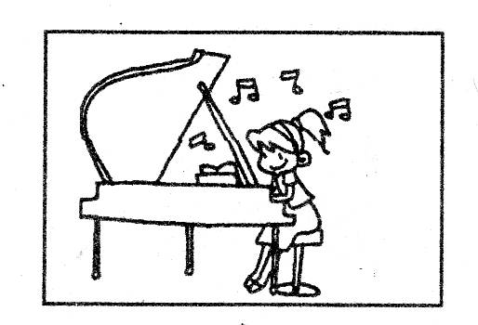
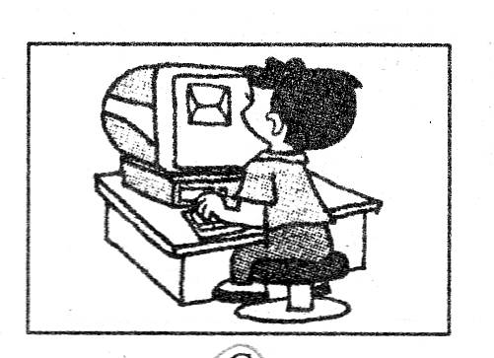
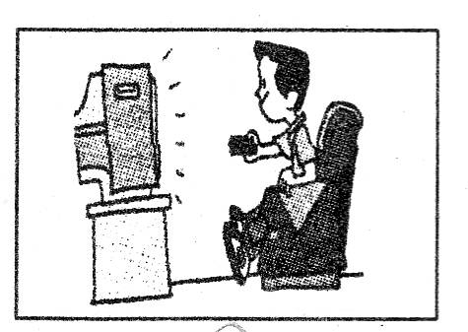

(A) (B) (C)
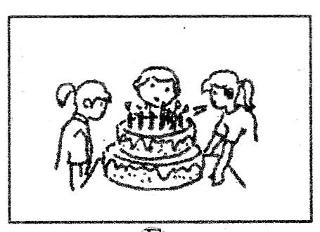
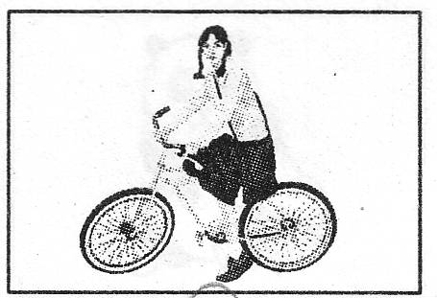
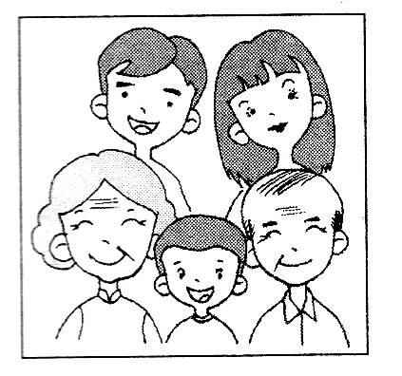

(D) (E) (F)

1．__________2.__________3.__________4.__________5.__________
2 .Listen to the dialogue and choose the best answer to the question you hear（根据你听到的对话和问题，选出最恰当的答案）：（共8分）
（ ）6.A.Two B. Three C. Four D. Five
（ ）7.A.He doesn’t like the style
B.He doesn’t like the color
C.The size is too big
D.The size is too small
( ) 8.A.He likes to write stories. B. He likes to takes photos.
C. He likes to watch TV. D. He likes to have sports.
( ) 9. A. Chinese. B. Maths. C. English. D. Science.
( )10.A.A police. B. An actor. C.A writer D.A Doctor
( )11.A.Ping-pong B. Football C. Basketball D. Swimming
( )12.A.They are talking about holidays in China.
B.They are talking about having a trip in Shanghai.
C.They are talking about how to go to shanghai.
D.They are talking about shopping in shanghai.
( )13. A. Once a week. B. Once a month.
C. Twice a week. D. Twice a year.
3.Liseten to the passage and tell whether the following statements are ture or false(判断下列句子是否符合你听到的短文的内容，符合的用“T”表示，不符合的“F”表示)：（共6分）
（ ）14.This passage just talks about the delicious food we can have in Beijing.
( ) 15.Beijing Roast Duck is the favourite food of the speaker.
( ) 16.The speaker thinks that Beijing is not a good place for shopping.
( ) 17.Xidan and Wangfujing Street are the business centre and traditional market.
( ) 18.You can take photos on the Great Wall.
( ) 19.You won’t have a good time there.
4.Listen to the dialogue and complete the following sentences(听对话，完成下列内容，每空格限填一词)：（共6分）
20.Ben wants to go to the _______.
21.Uncle John is coming to their house this ______.
22.The things in the Easy Supermarket are______.
23.Ben wants to buy _______and vegetables.
24.The girl wants to have some______drinks.
25.Uncle John will come by______.

Part2 Vocabulary and Grammar(第二部分 词汇和语法)

5.Choose the best answer(选择最恰当的答案)：（共15分）
（ ）26.Hans is ______university student. He will go to work next year.
A. an B. a C./ D. the
( ) 27.There is something wrong with my computer. May I use_____?
A. your B. yours C. you D. mine
( ) 28.As we all know, Paris is one of_____ cities in the world.
A. large B .larger C. largest D. the largest
( ) 29.Ben is now telling us something about the 2010 World Expo, because he_____ the EXPO.
A. has been to B. has gone to C. has been D. has gone
( ) 30.He looks as _______ as before..
A. the same strong B. stronger C. strong D. much strong
( ) 31.Do you remember ______ him for the first time?
A seeing B. to see C. saw D. sees
( ) 32.Every day my aunt types letters and _____ phones in the office.
A .answering B. asks C. answers D. calls
( ) 33._____great fun it is to fly kites in People’s Square!
A. How B. What C. What a D. How
( ) 34.If you go to the Culture Square, you _____a lot of pigeons there.
A. see B. saw C. have seen D. will see
( ) 35.The Opening Ceremony of the 16th Asian Games was held successfully in Guangzhou_____ November 12th 2010.
A .at B. in C .before D. on
( ) 36.Billy, is your mother cooking meat in the kitchen? It smells_____!
A. nice B. pretty C. well D. badly
( ) 37.Must I finish the work tonight?
____.You can do it tomorrow.
A. No, you needn’t B. Yes, you must
C .I’m afraid you can’t D. Yes, you can
( ) 38.We haven’t got many _____to make cakes. Will you go and get some?
A. milk B. apple C. eggs D. juice
( ) 39.This high building was built over 100 years ago. The underlined part means____.
A. less than B. more than C. a few D. a little
( ) 40.----Shall we go to watch “Swan Lake” at Shanghai Grand Theatre this weekend?
-------______
A. Never mind B. Of course
C. You’re welcome D. That’s great
6.Complete the sentences with the given words in their proper forms(用括号中所给的单词的恰当形式完成下列句子)：（共8分）
41.Have you got the_________ (invite) to his party?
42. We are all very ________(excite) about that trip.
43.You are old enough to take care of_____(you),Sandy.
44.What ______(surprise) news it is to go to the beach this weekend!
45.Do you know the ________(five) girl from the left in the photo?
46.Paper catches fire______(easy).
47.You’d better clean your_______(tooth) twice a day.
48.Ww can see some swans _______(swim) across the lake.
7.Rewrite the sentences as required.（按要求改写句子，每空格限填一词）：（共10分）
49.Mr Wang teaches us English in the school.（改为否定句）
Mr Wang ____ ______us English in the school.
50.My parents have already gone to Shanghai Science and Technology Museum.（改为一般疑问句）
______your parents gone to Shanghai Science and Technology Museum_______?
51.We can get to Pudong Airport by underground.（对画线部分提问）
_______ _______you get to Pudong Airport ?
52.Little Tommy is going to learn to ride a bicycle.（改为反意疑问句）
Little Tommy is going to learn to ride a bicycle, ______ ______?
53. How do you like the film ‘Aftershock’?（保持原句意思不变）
What do you _____ ______ the film ‘Aftershock’?
Part 3 Reading and Writing(第三部分 读写)

Reading Comprehension(阅读理解)：（共18分）
A
China is a great country with 5,000 years of history(历史). There are many places of interest in China. Some of them are fantastic(极好的) lakes, beautiful mountains and long rivers.
Many mountains, such as Mount Tai, Mount Emei, and Mount Hua are very famous. People go to Mount Tai to see the sunrise. Among the rivers the Yangtze River is the longest one and the second longest one is the Yellow River. They are the birthplaces of Chinese culture(文化).
Have you heard of the love story about Xu Xian and White Snake? It is said that the story happened on the West Lake. It is in Hang Zhou, which is called “a beautiful paradise for sightseeing”. What’s more, there are some mountains around the West Lake.This makes a beautiful picture! Every year ,many tourists go there to see the wonderful scenery(景色).
The West Lake is also famous for some nice poems written by Bai Juyi and Su Dongpo.
Have you ever been to the West Lake? If not , look for a good chance to go to fantastic place. Act now!
True or False(判断下列句子是否符合短文内容，符合的用“T”表示，不符合的用“F”表示)（6分）
( )54.China is a great country with 500 years of history.
( )55.China is only famous for its beautiful mountains.
( )56.People can see the sunrise on Mount Tai.
( )57.The Yangtze River and the West Lake are the birthplaces of Chinese culture.
( )58.A lot of tourists go to the West Lake to enjoy the beautiful scenery every year.
( )59.Bai Juyi and Su Dongpo wrote some poems, making the West Lake famous.

B
Are you eager to go back to school? Do you hope to do a lot of homework every evening? Are you interested in your classes? Who do you want to teach you subjects? Why do you like them? Maybe you have lots of questions before school starts.
Well, I want to give you some advice on these questions.
Firstly, keep calm. Don’t worry about all the questions. Put your heart into learning. You can find something you are interested in. Do it actively.
Secondly, try to finish your homework quickly. Don’t spend a lot of time on it. Do more reading and writing in English .Think about the questions and work them out at once. Don’t stay up late. You can’t study well the next day.
Finally, invent something instead of copying. If you can remember the words in your own way, you can tell your teachers you don’t like the way of copying them again and again .Be sure, you must pass the test .I think your teachers will agree with you . And they can give you some interesting work to do.
School is really a good place for us to learn and make friends. Believe in your teachers and yourself. You are the best one and can do everything well.
Choose the best answer(选择最恰当的答案)：（6分）
（ ）60.Why does the writer write this passage?
- To give students some good ways of learning.
- To tell students to write more and speak more
- To tell students not to do their homework.
- To tell students not to listen to their teachers.
( ) 61.The word “calm” in the third paragraph probably means _____in Chinese.
- 紧张的
- 烦躁的
- 平静的
- 快乐的
( )62.How many ways are there in this passage?
A.4 B.3 C.2 D.5
( )63.What dose the writer tell students to do about their homework..
- They should spend a lot of time on it
- They should stay up late doing their homework.
- They should try to finish it in a short time.
- They needn’t do it at all.
( )64.What do you have to do if you use a new way to remember words?
- Copy the words many times.
- Do more reading and speaking.
- Ask your teacher to use your way too.
- Make sure to pass the exam.
( )65.Is school a good place for students to learn things?
A. Yes, it is. B. No , it isn’t. C. We don’t know D. It’s hard to say

C
Homes and families | Many British people live in houses ,not flats .Many houses have gardens.
Life | Many office workers start work at about 9 in the morning and finish at about 5 or 6 in the afternoon .Many people don’t go home for lunch .They just have a quick meal.
School Life | School starts at 9 a.m., and finishes at about 3:30 p.m. Many children go to school when they are 4 or 5 years old, and leave when they are 16 or 17.
Shops | Many shops open at about 9 a.m. Usually they don’t close for lunch. And they usually close at about 6 p.m.
（根据短文内容回答下列问题）：（6分）
66.Do many British people live in flats or houses ?
_____________________________________________
67.What time do many office workers start work in the morning?
________________________________________________________
68.Do many office workers have lunch at home?
__________________________________________________
69.How many years are the children at school in British usually?
_____________________________________________________
70.Can you buy things in the shops at lunchtime?
__________________________________________
71.How long do the shops open usually?

Cloze test(完形填空)：（共14分）
A：Choose the words or expressions to complete the passage(选择最恰当的单词或词语，完成短文)
I always remember good things and bad things about my childhood. At that time, we lived 72, and my parents always got up early in the morning to feed the cows and sheep .I still remember the nice cooking smell of the breakfast. Then I 73_ the bed ,washed quickly and ran downstairs .My breakfast was 74_ for me on the table.
In winter, the weather was always very cold. The house didn’t have any heating(暖气),so we had to wear 75 clothes in bed! When we woke up in the morning ,there was frost(霜) on the outside and sometimes inside of the window! The life was 76 hard for us!
I also remember 77 our holidays by the sea. We went to the same place every year. It was a beautiful place. I felt very 78 there. Whenever(每当) we left there to go back home, I always kept crying. I will never forget my childhood.
( )72. A. near a river B. on a farm C. on a busy street D. in a city
( )73. A. left B. lay in C. jumped out of D. got into
( )74. A. looking B. waiting C. asking D .paying
( )75 A. beautiful B. old C. new D. heavy
( )76. A. really B. only C. finally D. easily
( )77 A. finishing B. giving C. spending D. wasting
( )78 A. busy B. interested C. healthy D. happy

B:Read the passage and fill in the blanks with proper words(在短文的空格内填入适当的词，使其内容通顺，每一个限填一词，首字母已给)：（7分）
Do you really care about your parents? Hearing this question, most of us may give a quick a 79_”Of course, I do.” But maybe you don’t.
It is true that all parents remember clearly when to c_80____ their children’s birthdays. However, it is a pity that few children know when their parents’ birthdays are. Most parents can easily name their children’s favorite food .But some children do not know w 81_ their parents like.
Sometimes parents complain(抱怨)that their children don’t like talking with them. Children are g 82 up and the generation gap(代沟) is widening.
If you love your parents well, let them f 83 your love. Give them a birthday gift: help them do some housework. OK ? Don’t a 84 say something against(反对) your parents. Try to talk with them more often and understand them more.
From now on , let’s learn to care about our parents . If we do like that , our families must be f 85 of more happiness, love and care.
79.______80.______81.______82._______83.________84._______85.________

10.Writing(作文)：（10分）
Write a passage of at least 50 words about the topic “What would you like to… in the future? ”（以“将来我想……”为题写一篇不少于50个词的短文，标点符合不占格）

What would you like to… in the future?

听力原文
I. Listen to the sentence and choose the right picture
1. Mary usually goes to school by bicycle. (E)
2. My friend Lucy can play the piano very well. (C)
3. I’d like to stay home and watch TV on Sundays. (B)
4. This is a photo of the Li family. The boy in the middle is Ben. (F)
5. I’ll have a birthday party tonight. Would you like to come? (D)
2.Listen to the dialogue and choose the best answer to the question you hear (根据你听到的对话和问题，选出最佳答案)
(6). M: My parents and I are going to Shanghai next week.
W: Oh, that’s cool! What do you want to visit in Shanghai?
M: We want to visit the Shanghai Museum, People’s Square, and Century Park.
W: I wish you a good time!
Q: How many places do the boy and his parents want to visit in Shanghai?
(7).W: Can I help you?
M: Yes. I bought this pair of shoes here yesterday. I like the style, but can you change them for white ones? I don’t like black.
Q: Why does the man want to change the shoes?
(8).M: What do you like to do in your free time?
W: I like to take photos. Do you like to take photos?
M: No, I like to write stories when I’m free.
Q: What does the boy like to do in his free time?
(9).M: Do you like Maths, Ann?
W: Yes. Maths is my favourite subject. But I don’t like Chinese.
M: Me, neither. Chinese is too hard to learn.
W: Yes, you are right.
Q; What do they think is hard to learn?
(10).W: What would you like to be in the future?
M: I’d like to be a police officer. It’s interesting. What about you?
W: I want to be a doctor. I like to help others.
Q: What does the girl want to be in the future?
(11).W: Dad, what was your favourite sport when you were a student?
M: Football. I was the captain of the school team.
W: Cool. I like ping-pong best.
Q: What sport does the girl like best?
(12).W: Tom, do you know People’s Square in Shanghai?
M: Yes, of course. It is the centre of Shanghai. It is a huge open area with green grass, trees and fountains. Would you like to visit the place?
W: Yes, I would like to. Let’s go there this summer holiday, shall we?
M: OK. That’s a good idea.
Q: What are the two speakers talking about?
(13).M: Where are you going, May?
W: I’m going to City Sports Centre.
M: How often does do you go there?
W: Once a week.
Q: How often does May go to City Sports Centre ?
3.Listen to the passage and tell whether the following statements are true or false(判断下列句子是否符合你听到的短文内容，符合的用“T”表示，不符合的用“F”表示)
I am glad to tell you something about Beijing. There are many places for eating, shopping and sightseeing. Do you know Beijing Roast Duck? It is so famous and delicious that people all over the world like eating it. If you want to go shopping in Beijing, Xidan and Wangfujing Street are the best choices. They are the business centre and traditional market. There are also many places of interest in Beijing. Such as the Great Wall, Tiananmen Square and Beijing Olympic Park. Did you hear “He who has never been to the Great Wall is not a true man”. And if you go there you can take photos and see beautiful scenery. I think you will have a good time in Beijing.
4.Listen to the dialogue and complete the following sentences(听对话，完成下列内容，每空格限填一词).
W: Ben, where are you going?
M: I’m going to the supermarket. Uncle John is coming to our house this evening, you know.
W: Oh, I forgot about that. Which supermarket are you going to?
M: I’m going to Easy Supermarket.
W: Why do you like going there? Are the things there cheap?
M: Yes, they’re cheap.
W: Oh, what do you want to buy?
M: I want to buy meat and vegetables.
W: Buy some cold drinks. It’s hot today.
M: OK. Remember to meet him at about six o’clock at the bus stop.
W: No problem.

答案
  - 1-5 E C B F D
  - 6-10 BBAAD 11-13ABA
  - 14-19 FFFTTF
  - 20.supermarket 21.evening 22.cheap 23.meat 24.cold 25.bus
  - 26-30 BBDAC 31-35 ACBDD 36-40 AACBD
  - 41.invitation 42.excited 43.yourself 44.surprising 45.fifth 46.easily
47.teeth 48.swimming
7. 49.doesn’t teach 50.Have ; yet 51.How can 52.isn’t he 53.think of
8. A:54-59 FFTFTT
B:60-65 ACBCDA
C:66. In houses 67.At about 9. 68. .No,they don’t 69.Twelve years.
70.Yes,we can. 71.Nine hours
9. A:72-78 BCBDACD
B:79. answer 80.celebrate 81.what 82.growing 83.feel
84.always 85.full

