2009学年第一学期期中试卷
七年级英语
(答题时间为90分钟, 满分100分, 所有答案必须写在答题纸上)
Paper 1 Listening (第一卷 听力)(共25分)
I. Listen and choose the right picture (根据你听到的内容, 选出相应的图片): (共5分)
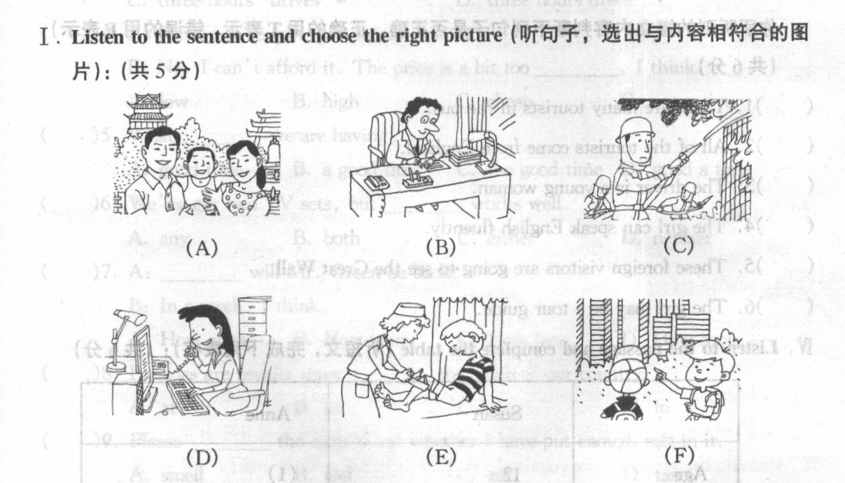

1. ( ) 2. ( ) 3. ( ) 4. ( ) 5. ( )
II. Listen to the dialogue and choose the best answer to the question you hear (根据你所听到的对话和问题, 选出最恰当的答案): (共8分)
( )6. A. On foot. B. By bus.
C. By bike. D. By underground.
( )7. A. Near the window. B. In front of the TV.
C. Next to the plant. D. Near the table.
( )8. A. An architect. B. A doctor.
C. A fireman. D. A removal man.
( ) 9. A. In the restaurant. B. At the hotel.
C. At the travel agency. D. In the shop.
( ) 10. A. A new flat. B. A TV set.
C. A sofa. D. A cupboard.
( )11. A. A black puppy. B. A brown puppy.
C. A white puppy. D. A black and white puppy.
( ) 12. A. The U.S.A. B. Britain.
C. Canada. D. Australia.
( )13. A. 400 yuan. B. 450 yuan.
C. 405 yuan. D. 415 yuan.
III. Listen to the passage and tell whether the following statements are true or false (判断下列句子是否符合你所听到的短文内容, 符合的用 “T”表示, 不符合的用 “F”表示): (共6分)
( ) 14. Thailand is not far from our country.
( ) 15. Many people have been to Thailand.
( ) 16. Tourists can wear T-shirts or skirts there.
( ) 17.Chinese people don’t like Thailand food because it’s spicy.
( ) 18. The people in Thailand don’t know Chinese. So Chinese
tourists should speak English with them.
( ) 19.People can have a trip around Singapore, Malaysia(马来西亚) and Thailand in a week.
IV. Listen to the passage and complete the table (听短文, 完成下列表格): (共6分)
A Smiling Angel(天使)
Name: | Song Xiaobo
Birthday: | on (20) 23,1983
Height: | 185 cm
Weight: | (2 1) kg
Birth place: | (22 )
Hobby: | (23) , shopping, surfing the Internet and  (24) as well(也)
Favourite Colours: | black, blue, (25)
20. _______ 21. _______ 22. _______ 23. ________24. _______ 25.______

Paper 2 Vocabulary and Grammar
(第二卷 词汇和语法)(共38分)
V. Choose the best answer (选择最恰当的答案, 用A、B、C或D表示, 填入空格内): (共18分)
( )26. _____ SPCA officer in blue is my uncle. How cool he looks!
A. A B. An C. The D. /
( ) 27. My new bedroom is a nice room _____ a big balcony.
A. has B. of C. with D. in
( )28. In Shanghai, more than _____ people started learning first
aid skills(急救技能).
A. thousand B. thousands of
C. two thousands D. two thousand
( ) 29. Connie Marks comes from _____.
A. America B. Japanese C. Indian D. Australian
( ) 30. ---- What do you think of Bob’s suggestion?
---- Well, it sounds(听起来) great, _____ it is not useful.
A. and B. or C. but D. so
( )31. There _____ a lot of fresh vegetables and fish in the market.
A. have B. has C. are D. is
( ) 32. David is very busy. He moves _____ furniture to people’s new flats every day.
A. a few B. many C. much D. a little
( ) 33. I haven’t seen you for a long time. You look much _____ than before.
A. taller B. tall C. tallest D. very tall
( )34. ---- _____ will you take your dog to the countryside for a walk?
---- Once a week.
A. How soon B. How often C. How long D. How many times
( )35. We _____ like to help people in Sichuan to rebuild their homes.
A. should B. had C. would D. could
( ) 36. The World Expo in shanghai _____ the world a surprise on May 1 ,2010.
A. gives B. will give C. gave D. has given
( ) 37. My parents _____ just _____ back from Beijing.
A. has ... come B. has ... came
C. did ... came D. have ... come
( )38. It _____ me half an hour to go to school every day.
A. costs B. spends C. takes D. pays
( ) 39. I’m sorry I haven’t got any money. I’ve _____ my handbag at home.
A. missed B. left C. put D. forget
( )40. Jim’s mother is ill. He has to stay at home and _____ her.
A. look for B. look after C. look up D. look at
( )41. Jimmy can speak _____ German, but he knows ____ about Chinese.
A. many, few B. a few, little C. much, a few D. much, little
( )42. You can get the correct answer ______ this way.
A. on B. in C. by D. from
( ) 43. Everything on the earth ______ water and air to live.
A. need B. needs C. doesn’t need to D. needn’t
( ) 44. ---- Do you prefer tea or coffee?
---- _____.
A. Coffee, please. B. I like tea best.
C. Yes, I do. D. No, I don’t.
( ) 45. ---Must I water the flowers today?
---______. It’s going to rain.
A. Yes, you must. B. No, you needn’t.
C. No, you can’t. D. Yes, you needn’t.
VI. Complete the sentences with the given words in their proper forms (用括号中所给单词的适当形式完成下列句子): (共8分)
46.Tom lives on the ______ floor. (twelve)
47. There are many places of ________ in Nanjing. (interesting)
48. To her surprise, Judy’s missing child came back ________ last night. (safe)
49. Kung Fu Panda is the ____film of all the films I have ever seen. (good)
50. Mary prefers ________ food to British food. (Canada)
51. Did you buy an armchair for ________? (you)
52. Lots of ________ go to the Great Wall every year. (visit)
53.Jane is a _______ who is good at typing letters . (secre)

VII. Rewrite the sentences as required (按要求改写句子, 每空格限填一词): (共10分)
54. Jane has her breakfast on her way to school. (一般疑问句)
________ Jane ________ her breakfast on her way to school?
55. Put the small table on the rug, please. (否定句)
________ _______ the small table on the rug, please.
56. The booksellers will sell these books to us. (同义句)
We will ________ these books _______ the booksellers.
57. I’d like to live far away from busy roads. (划线提问)
_______ ________ you like to live?
58. The three astronauts went into space with Shenzhou VII on September, 25th. (划线提问)
________ ________ the three astronauts go into space with Shenzhou VII?

Paper 3 Reading and Writing
(第三卷 阅读和写话)(共37分)
VIII. Reading comprehension (阅读理解) (共27分)
(A)
True or False (判断下列句子是否符合短文内容, 符合的用 “T”表示, 不符合的用 “F”表示): (共5分)
For sale
￥956,000
﹡Garden Estate – Built in 2009
﹡3 bedrooms, 1 bathrooms, 1 living-room, 1 kitchen
﹡1 big balcony
﹡8 minutes to Nonggongshang Supermarket
﹡10 kilometres from the town centre.
For further information, please phone 68523383
Asks for Mrs Mary Lee
( )59. Garden Estate is an old estate.
( ) 60. The flat has seven rooms and one big balcony.
( ) 61. It takes over ten minutes to get to Nonggongshang Supermarket
from Garden Estate.
( ) 62. The flat costs more than nine hundred and fifty thousand yuan.
( ) 63. You can dial the number 68523383 to get more information.

(B)
Choose the best answer(根据短文内容,选择最恰当的答案):(共5分)
It was a cold and rainy afternoon in winter. Jackson was about to leave the office after a long day of work. He was quite tired. He locked the office door and took out his car keys. It was already quite dark outside. When he reached his car, he took out the keys and put the door key into the lock and turned it. The door wouldn’t open. Then he found that it was the wrong car. He tried very hard to find his own car but he was not able to find it. Finally he reported to the police about this. But when he arrived home, he found that his own car parked right at his front door. He did not lose his car. He didn’t drive his own car to work this morning.
( ) 64. Jackson left his office _____.
A. because it was cold. B. when it was raining
C. after he found his car
D. after he worked for a long day
( ) 65. He took out the car door key and put it into the lock _____.
A. and opened his car B. but he could not open the car
C. and he found a wrong car
D. and went home
( ) 66. He could not open the car because _____.
A. he lost his car key B. it was dark
C. he was tired D. it was not his car
( ) 67. He reported to the police that _____.
A. he could not open his car B. he lost his car key
C. he could not find his car D. he locked his car
( ) 68. Which of the following is NOT true?
A. Jackson lost his car. B. Jackson was careless.
C. Jackson did not drive his car to the office.
D. The weather was not fine that evening.

(C)
Choose the words or expressions and complete the passage(选择最恰当的单词或词语，完成短文):(共6分)
Learning English is great 69 for me because I can always find interesting ways to use English.
Once my friend and I saw some foreigners 70 in a store. A good idea suddenly come into my 71 . “Let’s pretend to be English speakers and do some shopping.” I said to my friend. We 72 to the shop assistant in English. She was confused(迷惑的). We 73 speaking English. So she had to introduce their products in English. 74 , we bought what we wanted and had a good laugh.
( ) 69. A. funny B. fun C. difficult D. easy
( ) 70. A. shopped B. shopping C. to shop D. shops
( )71. A. hand B. ear C. body D. head
( )72. A. told B. talked C. said D. took
( ) 73. A. stopped B.didn’t stop C. started D. didn’t start
( )74. A. However B. Next C. Finally D. Quickly

(D)
Read the passage and fill in the blanks (在短文的空格内填入适当的词，使其内容通顺，每空格限填一词，首字母已给):(共6分)
An Australian house is usually a one-storey building. It often has a l 75 room, a dining-room, two or three bedrooms, a bathroom and a kitchen. Australians like to move to a b 76 flat. When their family grows, they
n 77 more bedrooms and bathrooms and a “family room”—they can watch TV and play games there. There is also a p 78 for barbecues. In their gardens there are a lot of flowers and trees. Many Australians also use a part of their gardens to g 79 vegetables and fruit.
Houses in big cities are much more expensive than those in the countryside. They are becoming e 80 more expensive because more and more people are choosing to live in cities. It is more convenient(方便的) to live in cities with so many shops, cinemas and restaurants.
75. l_________ 76. b_________ 77. n_________ 78. p_________
79. g_________ 80.e
(E)
Answer the following questions(根据短文内容，回答下列问题):(共5分)
A Frenchman came to London to study English. He lived at Jack’s home. Every morning he did some reading by the window before he went to class.
Jack liked to keep birds. Every morning, he took his bird out of the room and hung(挂) the cage on his window upstairs.
One morning when Jack took out his birdcage and tried to hang it on the window upstairs, the cage suddenly fell out of his hand. He couldn’t catch it. So he shouted, “Look out!” As soon as the Frenchman heard the shout, he put his head out of the window and tried to see what was happening. The cage was just in time to hit him on the head! From then on, the Frenchman would be careful when he heard “Look out!”. He knew the real meaning of it.
81. What did the Frenchman come to London for?
He came to London _____________________________.
82. What did Jack do with his bird every morning?
Every morning he ___________________________ and hung the cage on his window upstairs.
83. Did Jack call the Frenchman to look out of the window?
_____________________________________________________.
84. What hit the Frenchman on the head?
______________ hit him on the head.
85. What does “Look out” really mean?
It means “_______________________________!”

X. Writing (作文): (共10分)
Write at least 60 words about the topic “My Favourite------”.
(以 “我最喜爱的------”为题, 写一篇不少于60字的短文。 要求意思明确，内容连贯，不少于60词，标点符号不计入总词数。 )

