2009学年度东方中学第一学期期末考试
六年级英语试卷 2009.1
Part 1 Listening (第一部分 听力) （共25分）
I．Listen and choose the right picture（根据你听到的句子，选出相应的图片）（共5分）

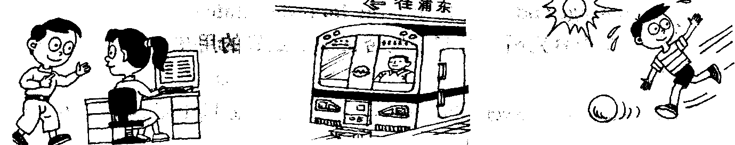
A B C
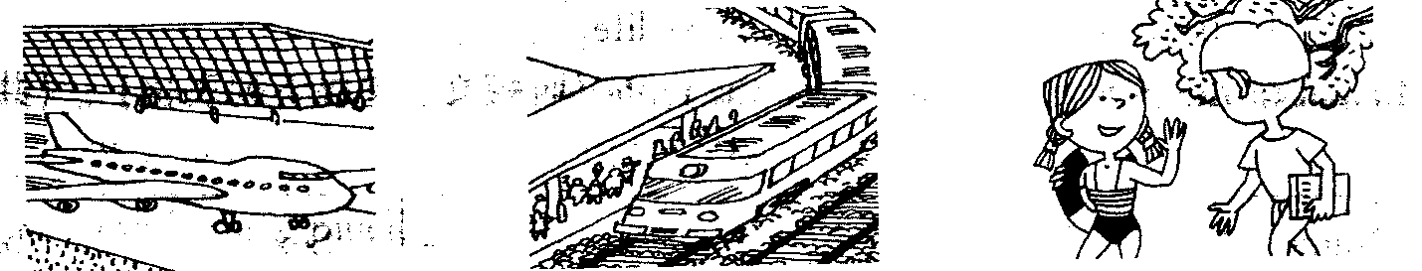
D E F
- ______ 2. _____ 3. ______ 4.______ 5. ______
II. Listen to the dialogue and then choose the best answer to the question you hear on the tape(根据你听到的对话和问题，选出最恰当的答案) (共8分)
( )1. A. 5:25 B. 5:30 C. 6:30 D. 6:35
( )2. A. Pilot B. Astronaut C. Policeman D. Engineer
( )3. A. Next weekend B. Next day C. This weekend D. On Saturdays
( )4. A. She is beautiful. B. She is never angry.
C. She is clever. D. She is always ready to help others.
( )5. A. By bus. B. By bicycle. C. On foot. D. By car.
( )6. A.40 minutes B. 25 minutes C. 15 minutes D. 50 minutes
( )7. A. Go to the cinema. B. Watch TV.
C. Go to the park. D. Do his homework.
( )8. A. Yes, she does. B. No, she doesn’t C. Yes, she is. D. No, she isn’t.
IV. Listen to the dialogue and tell whether the following statements are true or false (判断下列句子是否符合你听到的短文内容，符合的用“T”表示，不符合的用“F”表示) (共6分)
( )1. Jimmy is thirteen years old.
( )2. Their father and mother are in the same school.
( )3. Both of their parents teach maths.
( )4. There are many books in their family.
( )5. Dick and Jimmy like reading, but their parents don’t like.
( )6. Dick and Jimmy both want to be teachers.
V. Listen to the passage and complete the table（听短文，完成下列表格）(共6分)
Name: _____1_______ | School name: West Lake Middle School
Sex: boy | Favourite subjects: maths, _____4______
Age: _______2_______ | Sports: football, ______5_______
Family member: _____3_____, mother and I | Interest: collecting 6
1. 2. 3. 4. 5. 6.
Paper Two Vocabulary and Grammar （37%）
Ⅰ. Choose the best answer ( 选出最恰当的答案, 用A、B、C或D 表示 ) (共15分)
( )1.It takes Simon half ______ hour to get to school.
A. / B. the C. a D. an
( )2. We have rules _______ the road.
A. on B. at C. in D. of
( )3. I met my old friend _______ I was on a bus.
A. as B. after C. when D. before
( )4. The steamed fish tastes ________ with some garlic.
A. well B. bad C. delicious D. badly
( )5. We must not _______ in the library.
A. eating or drinking B. eat and drink
C. eating and drinking D. eat or drink
( )6. After changing bad habits, Jim is becoming as _________ as the others.
A. health B. healthier C. healthy D. the healthiest
( )7. I like traveling, and I have ________ many places.
A. been in B. been to C. been on D. gone to
( )8. I bought some books, and they _________ me 60 dollars.
A. spent B. paid C. cost D. used
( )9. He usually likes __________, but he’d like ________ fishing today.
A. dancing; going B. dancing; to go
C. to dance ; to go D. to dance; going
( )10. Tom and Jack, _____ talk noisily here.
A. mustn’t B. can’t C. don’t D. won’t
( )11. John has _______ nuts and _____ fried chicken.
A. plenty of ; a little B. a lot of; many
C. a little; much D. plenty of ; a few
( )12. I have bought some ______ the vegetable stall _____ the market.
A. in; in B. at; at C. at; in D. in; at
( )13. Everyone in our school promises _________ rubbish.
A. to leave B. to not leave C. not to leave D. leaving
( )14. I often see some shops __________.
A. on my way to home B. on his way home
C. on his way to go home D. on my way home
( )15. Ken usually ______ her homework in the evening, but today she _______ TV now.
A. is doing; is watching B. does; watch
C. is doing; watch D. does; is watching
( )16. ______ does he like chicken wings? He likes them because they are delicious.
A. How B. What C. Why D. Where

( )17. A: May I have some French fries? B: ___________
A. Of course, Here you are. B. Yes, you may.
C. Yes, you can. D. No, you may not.

Ⅱ.Complete the sentences with the given words in their proper form ( 用括号内所给单词的适当形式,完成下列句子 ) （共8分）
1. We need some _____________ (potato). Let’s buy some in the market.
2. Ice-cream and dumplings are in the _____________ (freeze) food section.
3. How about _____________ (skate) in winter?
4. The computer room in our school is on the ______________ (one) floor.
5. We mustn’t talk _______________ ( loud).
6. It took ___________ (he)two hours to finish the work.
7. Tomorrow will be Lucy’s birthday. Have you got her ____________ ?(invite)
8. You are not very fit. I’m sure your diet is ____________ . (healthy)

Ⅳ. Rewrite the sentences as required ( 按要求改写句子) (共12分)
- Terry often has lunch at school. (否定句)
Terry _______ often _______ lunch at school.
2. . Would you like rice for dinner? Would you like noodles for dinner? (改为选择疑问句)
Would you like rice _______ noodles ______dinner?
3. Don’t walk on grass when you are in the park. （保持相同意思）
_______ ______ walk on grass when you are in the park.
4. We can find this sing in a park. （对划线部分提问）
_______ _______ we find this sign?
5．Little Tom took the right apple. （对划线部分提问）
_______ apple _______ Little Tom take?
6. We must use the lift on the left. (划线提问)
______ _______ must we use?

Part 3 Reading and Writing （第三部分 阅读和写话）（共38分）
(A)
True or False (判断下列句子是否符合短文内容，符合的用“T”表示，不符合的用“F”表示)（共6分）
It is a fine Sunday morning. Wang Yin and Lin Ping want to go to the Great Wall. A t about 7:00, they are in a big bus. There are a lot of people in it. They are very happy to see the Green family in the bus, too. Wang Yin and Lin Ping give their seats(座位) to an old English couple（夫妇）. There are two other Chinese in the bus. One is a woman. She is driving the bus. The other is a young man. He can speak good English. He is now talking about the Great Wall to the people in the bus. All the other people are listening to him. They want to see the Great Wall very much. At about 8:00 they get there.
( )1. The people on the bus will go to see the Great Wall.
( )2. There are four Chinese on the bus.
( )3. The driver is a young man.
( )4. The young man could speak English well.
( )5. The young man is talking about the people in the bus.
( )6. It took them about one hour to get there by bus.
(B)
Choose the best answer（根据短文内容，选择最恰当的答案）（共6分）
A man was looking for things of old times. One day he came to a village(村子) and found a blue bowl(碗) which looked very old. The bowl was on the ground and a cat was drinking milk from it. A farmer, the owner(主人) of the cat, was sleeping beside the bowl. The man didn’t want to draw the farmer’s attention(引起……注意) to the value(价值) of the bowl, the man said to him in a soft voice, “What a nice cat you have! Won’t you sell it to me?”
“How much would you give me for it?” the farmer opened his eyes and asked.
“Twenty dollars(美元). Would it be enough?”
A few minutes later, the farmer agreed. After the man paid(付钱) the farmer, he said, “The cat will feel certainly thirsty. May I take the bowl for the cat?”
But the farmer said, “I’m sorry I can’t give it to you. Thanks to the bowl, I have already sold twenty cats.”
( )1. The man liked __________.
A. looking for old things B. travelling from village to village
C. meeting farmers D. buying cats
( )2. One day he came to _________ to look for something old.
A. a school B. a village C. a farm D. a field
( )3. The man was interested in(对……感兴趣) ___________.
A. the cat B. the farmer C. the bowl D. Both A and C
( )4. Why did the man want to buy the cat? Because__________.
A. it was very lovely.
B. the cat cost more money than the bowl
C. he thought he could get the bowl if he bought the cat
D. he hadn’t enough money to buy both the cat and the bowl
( )5. The farmer didn’t give the bowl to the man because he wanted to________.
A. give it to others B. sell more cats
C. sell more bowls D. use the bowl himself
( )6. From the story we can see that the farmer _________.
A. had many bowls B. was very poor
C. didn’t like cats D. was cleverer
(C)
Answer the question (根据短文内容回答下列问题) （共6分）
James Williams comes from America. People call him “Big Cat” because he’s two metres tall. He is famous(出名的) because he plays for the Chicago Bears(芝加哥公牛队)，an American football team. American football is different from European(欧洲) football. American football players need to be big and strong, so James needs to eat a lot.
Every day James has three big meals. For breakfast he has orange juice, fruit, bread, milk, eggs, and cakes. For lunch he has fish, meat, vegetables, and ice cream. He loves ice cream.
In the evening he has his big meal—tomato soup, pork and beef, potatoes, chicken, rice, and his favourite chocolate cakes.
But that isn’t everything. James also eats between meals—bread, hamburgers, sweets, and two or three bars of chocolate!
- How tall is James Williams?

- Where does James come from?
_____________
- Why is he famous?

4. What does James have for breakfast?

5. Does he like chocolate cakes best?

6. How are American football players?

II. Cloze test (完形填空)
(E)
Choose the words or expressions and complete the passage (选择最恰当的单词或词语完成短文) ）（共5分）
This is the Forest Park .It is in the east part of Shanghai and near the Huangpu River. The park is very beautiful. There are lots of trees and flowers in it. Some trees are ________. Some trees are short. Some flowers are yellow. Some flowers are white. There is ________a lake in it. It is very big. And there are ________boats on it. Look, many boys and girls are playing over there. Some are singing________ the trees. Some are playing ball games near the lake. Their teacher is ________them. They are having a good time.
( ) 1. A. long B. big C . high D. tall
( ) 2. A. also B. too C. still D .yet
( ) 3.A .much B. lot of C. some D. any
( ) 4. A .up B. in C. on D. under
( ) 5. A. with B. join C. take part in D. help
(F)
Read the passage and fill in the blanks with proper words（在短文的空格内填入适当的词，使其内容通顺，每空格限填一词，首字母已给） (共5分)
Dear Jane,
Hello! My name is Sally. I’m twelve and I go to No. 1 Middle School. I’m very h___1_____ to have a pen-friend in England.
Here’s a photo of my f____2_____. My mother and father are at the back. I’m standing o___3____ the right by my father, and my brother is standing in front of us. He is eight. His name is John. I’ve got two cousins as well. They b___4___ go to university(大学). Their names are Simon and Debbie.
Please write and t_____5_____ me about your family.
Love
Sally
（1）h （2）f （3）o （4）b （ 5）t

III. Writing (写话): （共10分)
Write a short passage of at least 50 words about the topic “Having a picnic” (请以“野餐”为题写不少于60个词的短文，标点符号不占格。)
Suggested questions: （供参考）
1. When and where will you have a picnic? / When and where did you have a picnic?
2. What will you buy for the picnic? Why? / What did you buy for the picnic? Why?

